|  |  |  |  |  |
| --- | --- | --- | --- | --- |
|  | Present Positive | Present Negative | Past Positive | Past Negative |
| **る** | **Drop る replace with ～ます** | **～ません** | **～ました** | **～ませんでした** |
|  |  |  |  |  |
| **う** | **～います** | **～いません** | **～いました** | **～いませんでした** |
|  |  |  |  |  |

|  |  |  |
| --- | --- | --- |
|  | Affirmative | Negative |
| Present | **です** | **じゃないです；じゃありません；ではありません** |
| Past | **でした** | **じゃなかったです；じゃありませんでした；ではありませんでした** |

**いー**adjectives conjugation

|  |  |  |  |  |  |  |  |
| --- | --- | --- | --- | --- | --- | --- | --- |
|  |  | Affirmative | |  | Negative | |  |
| Present |  | **小さいです** | |  | **小さくないです** | |  |
| Past |  | **小さかったです** | | | **小さくなかったです** | |  |
| **いい**-adjective conjugations | | | |  |  |  |  |
|  |  | | |  | |  |  |
|  | Affirmative | |  | Negative | |  |  |
| Present | **いいです** | |  | **よくないです** | |  |  |
|  |  |  |  |  |  |  |  |
| Past | **よかったです** | |  | **よくなかったです** | |  |  |
| **なー**adjectives conjugation | | | |  |  |  |  |
|  |  |  | |  |  | |  |
|  |  | Affirmative | |  | Negative | |  |
| Present |  | **元気です** | |  | **元気じゃないです** | |  |
| Past |  | **元気でした** | |  | **元気じゃなかったです** | |  |

|  |  |  |
| --- | --- | --- |
| Past Tense | Affirmative | Negative |
| -ru verb (1) | る -> ました | る -> ません　でした |
| -u verb (5) | -(*u*) -> (*i*)ました | (*u*) -> (*i*)ません　でした |
|  |  | す->し |

**てー**form conjugation

|  |  |  |  |  |  |
| --- | --- | --- | --- | --- | --- |
| Verb | Final | **て**-form | Other | Regular | **て**-form |
| **る** | **る** | **○て** | **い　-　adjective** | **安い** | **安くて** |
|  | **る**,**う**,**つ** | **○って** | **いい** | **いい** | **よくて** |
|  | **む**, **ぬ**, **ぶ** | **○んで** |  |  |  |
| **う** | **く** | **○いて** | **な　-　adjective** | **元気** | **元気で** |
|  | **ぐ** | **○いで** | Noun +**です** | **日本人です** | **日本人で** |
|  | **す** | **○して** |  |  |  |
| Other | **ある** | **あって** |  |  |  |
| **する** | **して** |  |  |  |  |
| **くる** | **きて** |  |  |  |  |
| **いく** | **いって** |  |  |  |  |

|  |  |  |
| --- | --- | --- |
| **Present Short Form** | | |
|  | Affirmative | Negative |
| う- Verb | *Dictionary Form* | (Drop dictionary form ending *u* sound) -> (*a* sound) + ない |
| る- Verb | *Dictionary Form* | *Drop* る*from Dictionary Form* + ない |
| い-Adj | *Dictionary Form* | Replaceい with く-> くない |
| な-Adj | Replace ですwith だ | +じゃない |
| Noun+です | Replace ですwith だ | +じゃない |
| Exception | う | う-> わ |

|  |  |  |  |  |  |  |
| --- | --- | --- | --- | --- | --- | --- |
| **Present Negative Short Form** | | | | |  |  |
|  | | Verb | Negative | |  |  |
| Irregular Verb | | する | しない | |  |  |
|  | | くる | こない | |  |  |
| Exception | | ある | ない | |  |  |
|  | |  |  | |  |  |
|  | |  |  | |  |  |
| **Past Short Form** | | | |  | |  |
|  | Affirmative | | | Negative | | |
| Verb | -te: て/で -> た/だ | | | Present short negative: lastい-> かった | | |
| う | Drop う + った | | |  | | |
| る | Drop る+た | | |  | | |
| い-Adj | +かった | | | Present short negative: lastい-> かった | | |
| な-Adj | +だった | | | Present short negative: last い-> かった | | |
| Noun+です | +だった | | | Present short negative: last い-> かった | | |

Lesson 7: joining sentences

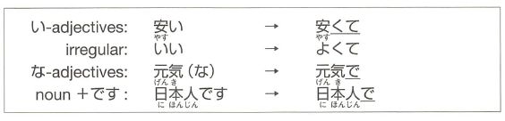

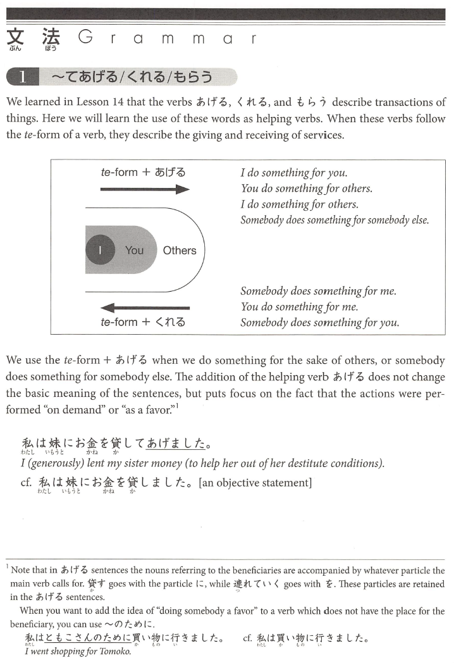

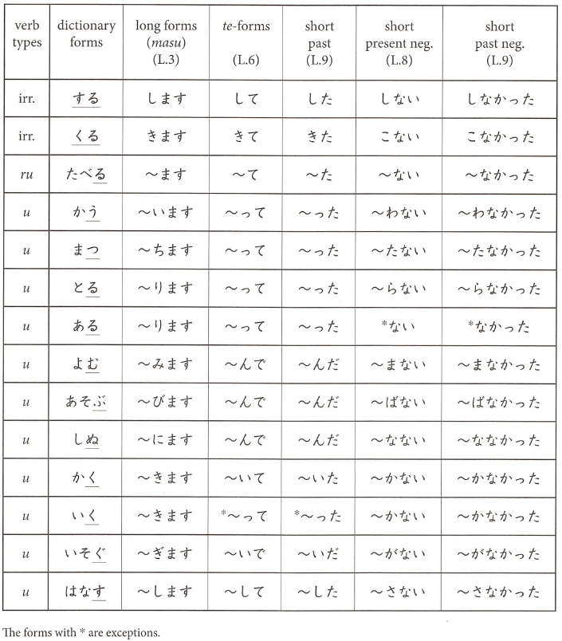

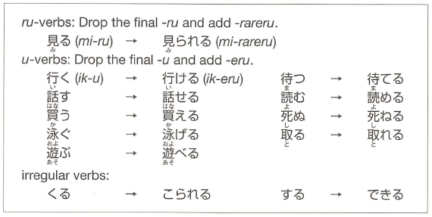Lesson 13 Potential

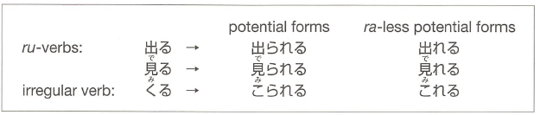ra-less potential form

Conjugation pattern (affirmative/negative):

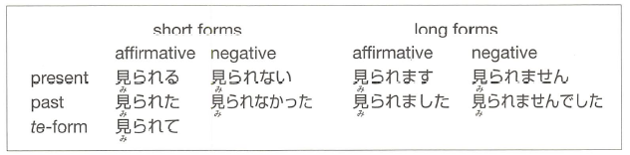

Particle is をorが

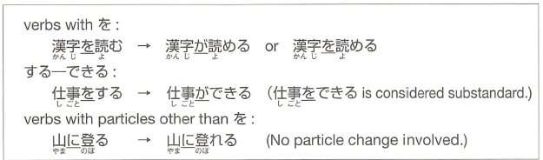

Chapter 14

Chapter 15

Volitional form – suggest a plan

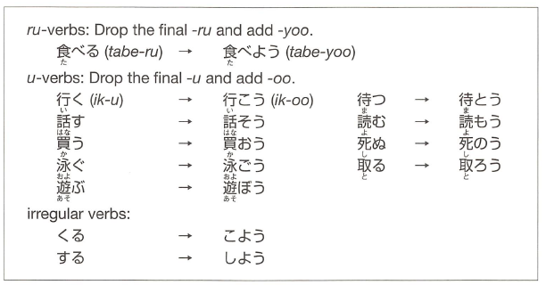

Chapter 21

## Passive form

Lesson 22:

Causative:

Causative Sentence structure

ask for permission to do something and to volunteer to do something:

## ~ば conditional (if A, then B)

## Lesson 23

## Causative-passive Sentence Verbs

## Causative-passive Sentence Structure

